IOT PROJECT PHASE-5

TITLE: DEVELOPMENT OF SMART RESTROOM USING IOT

INTRODUCTION:

In the rapidly evolving landscape of smart technology, the integration of the Internet of Things (IoT) has revolutionized various aspects of daily life. As the demand for enhanced efficiency, sustainability, and user experience continues to rise, the application of IoT in the realm of public facilities has become a critical focus. In this context, the concept of a smart restroom, empowered by IoT, has emerged as a pioneering solution to address the challenges associated with conventional public restroom management.

OBJECTIVES:

This project aims to introduce an innovative approach to restroom management through the integration of IoT devices and intelligent systems. By leveraging cutting-edge sensor technologies, data analytics, and automation, our smart restroom project seeks to redefine the user experience, optimize resource utilization, and ensure a higher standard of hygiene and cleanliness. Through real-time monitoring, predictive maintenance, and user-centric design, this initiative endeavors to create a seamless, efficient, and sustainable restroom environment that aligns with the needs and expectations of modern society.

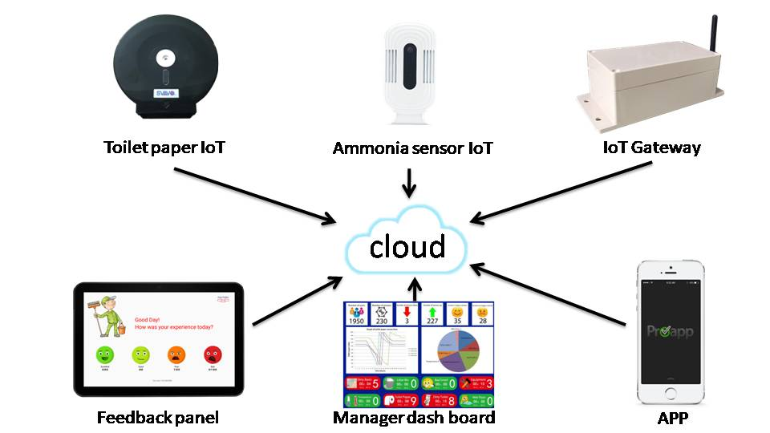

With a focus on enhancing convenience, safety and environmental sustainability, our smart restroom project is poised to set a new benchmark for public facilities. By enabling remote monitoring, proactive maintenance, and data-driven decision-making, we aim to establish a model that not only improves user satisfaction but also contributes to the overall well-being of the community. By combining advanced IoT technology with a user-centric approach, this project represents a significant step forward in reimagining the future of public restroom infrastructure and manage.

COMPONENTS REQUIRED:

A smart restroom project utilizing IoT involves the integration of various components to enable a seamless, connected, and efficient system. Below are some essential components required for such a project:

Sensors:



Sensors play a crucial role in collecting data and enabling various functionalities within the smart restroom. Different types of sensors may be employed, including occupancy sensors, motion sensors, temperature sensors, humidity sensors, and air quality sensors, to monitor usage patterns, detect occupancy, and maintain optimal environmental conditions.

Without the process of the sensor it is not possible to detect the condition of the restroom condition

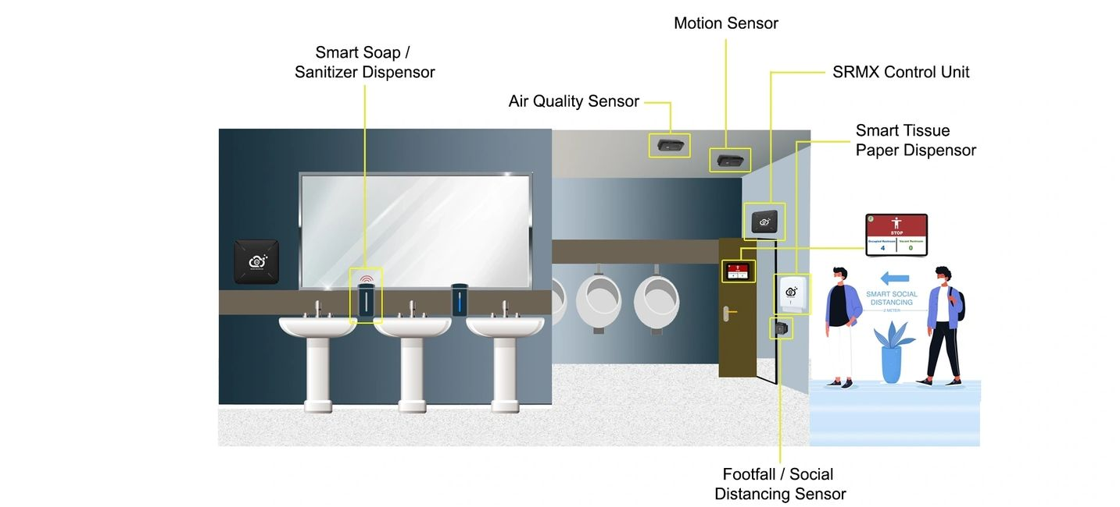



Actuators:



Actuators are devices that translate the digital signals received from the sensors into physical actions. In a smart restroom, actuators may control automated systems such as smart faucets, automated flush systems, smart hand dryers, and automated doors, thereby enhancing the efficiency and hygiene of the restroom environment.

Connectivity Devices:



IoT relies heavily on connectivity to enable communication between different components. Wi-Fi or other connectivity protocols like Bluetooth or Zigbee are often used to ensure seamless communication between sensors, actuators, and the central control system, facilitating real-time data transmission and analysis.

Microcontrollers or Microprocessors:



Microcontrollers or microprocessors act as the brain of the IoT system, enabling data processing and decision-making. They facilitate the integration of sensors, connectivity devices, and actuators, allowing for the execution of automated tasks based on predefined **algorithms or user-defined** parameters.

Data Storage and Processing Unit:



A robust data storage and processing unit is essential for collecting, storing, and analyzing the data generated by the sensors. This unit can be a local server or cloud-based storage, which enables the processing of large datasets, real-time analytics, and the generation of actionable insights for efficient management and decision-making.

User Interface (UI):



An intuitive and user-friendly interface is crucial for user interaction and control. This interface can be in the form of a mobile application, a web-based dashboard, or touch-screen displays within the restroom, allowing users or administrators to monitor and control various restroom features, access information, and provide feedback.

Security and Privacy Measures:



Implementing robust security measures is essential to safeguard the data and ensure the privacy of users. This may involve the use of encryption protocols, secure data transmission, and access control mechanisms to protect the system from potential cyber threats and unauthorized access.

Power Management Systems:



Efficient power management systems, including energy harvesting technologies and power-saving mechanisms, are crucial for ensuring the sustainability and cost-effectiveness of the smart restroom. This helps to optimize energy usage and reduce overall operational costs.

By integrating these essential components, a smart restroom project can effectively leverage IoT technology to create a connected and intelligent restroom environment that enhances user experience, optimizes resource utilization, and promotes sustainable management practices.

CIRCUIT DIAGRAM:

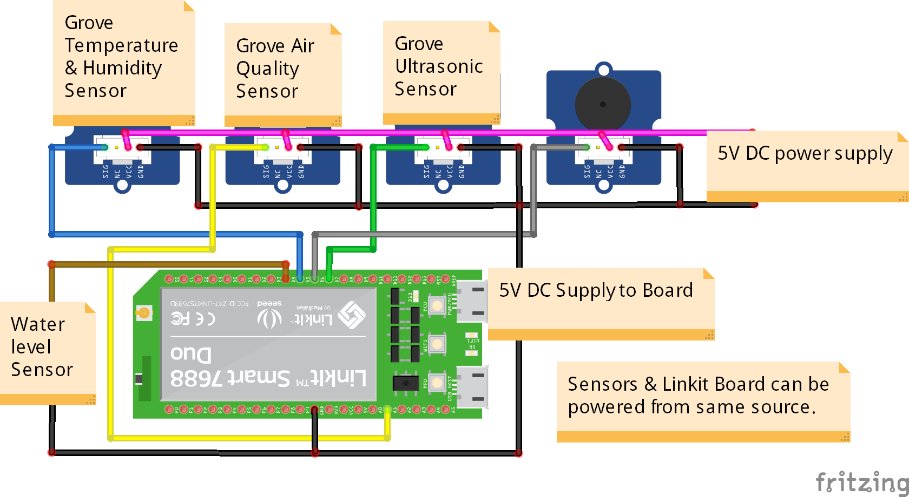Top of Form

PROJECT DEVELOPMENT:

Developing a smart restroom project using IoT involves several key steps. Here is a general outline to guide you through the process:

Define Project Scope and Objectives:

Identify the specific goals and functionalities of the smart restroom project.



Determine the target audience and user requirements.



Select the Required Components:

Choose appropriate sensors for occupancy, motion detection, and environmental monitoring.



Select actuators for controlling water flow, lights, and other restroom facilities.



Pick a suitable microcontroller and communication module for data processing and transmission.



Design the Circuit and System Architecture:

Create a detailed circuit diagram that includes all the selected components.



Determine the integration of the sensors, microcontroller, actuators, and communication modules.



Plan for power supply and connectivity requirements.



Develop the Software:

Write code for the microcontroller to handle sensor data and control the actuators.



Implement communication protocols to connect the system to the IoT platform or cloud.



Integrate the Hardware and Software:

Assemble the hardware components according to the circuit diagram.



Upload the developed software onto the microcontroller.



Test the integrated system to ensure proper functionality and communication.

Implement IoT Connectivity:

Configure the communication module to connect the system to an IoT platform or cloud service.



Set up data transmission and establish secure communication protocols.



User Interface Development:

Design a user interface for remote monitoring and control of the smart restroom.



Develop a user-friendly dashboard for real-time data visualization and system management.



Testing and Quality Assurance:

Conduct comprehensive testing to verify the accuracy and reliability of the system.



Identify and address any potential issues or bugs in the hardware or software.



Deployment and Monitoring:

Deploy the smart restroom system in the desired location.



Monitor the system's performance and collect user feedback for further improvements.



Maintenance and Updates:

Establish a maintenance plan to ensure the system operates efficiently over time.



Regularly update the software and firmware to incorporate new features and security patches.



IOT DEVICES SETUP:

In a smart restroom project using IoT, various devices are integrated to create a connected and automated system. These devices enable the collection of data, remote monitoring, and control of different aspects of the restroom. Here are some common IoT devices that can be set up in a smart restroom project:

1. Occupancy Sensors:

These sensors detect whether the restroom is occupied, enabling the system to manage resources more efficiently and provide real-time occupancy information to users.

2. Motion Sensors:

Motion sensors can be used to detect human movement, allowing the system to activate lights or ventilation systems when someone enters the restroom and deactivate them when the area is unoccupied.

3. Environmental Sensors:

These sensors monitor environmental conditions such as temperature, humidity, and air quality. They help maintain a comfortable and hygienic restroom environment.

4. Water Flow Sensors:

Water flow sensors can be installed to monitor and manage water usage, ensuring efficient water management and conservation within the restroom.

5. Smart Dispensers:

Automated soap dispensers, paper towel dispensers, and air fresheners can be integrated into the system to provide touchless operation and manage supply levels based on usage patterns.

6. Smart Mirrors:

Mirrors with integrated displays can provide users with information such as weather updates, news, or advertisements. They can also be used for providing guidance or instructions within the restroom.

7. Automatic Flush Systems:

IoT-enabled flush systems can automatically manage flushing cycles, ensuring proper sanitation and water efficiency.

8. Smart Locks and Entry Systems:

These systems can provide secure and controlled access to the restroom, with features such as keyless entry, access control based on user permissions, and remote monitoring of entry and exit activities.

9. Remote Monitoring Cameras:

Cameras can be installed to monitor the overall cleanliness and usage of the restroom. These cameras can also be used for security purposes and to ensure compliance with hygiene standards.

10. IoT Gateway Devices:

These devices facilitate communication between the various sensors and the central control system, enabling data transmission and management of the entire IoT ecosystem within the restroom.

11. Control Panels:

Control panels can be set up to allow manual control of various restroom functions, providing a backup solution in case of connectivity issues or system malfunctions.

Integrating these IoT devices in a smart restroom project can significantly improve user experience, promote resource efficiency, and enhance the overall management and maintenance of the restroom facility.

CODE IMPLEMENTATION:

# Import necessary libraries

import RPi.GPIO as GPIO

import time

import requests

# Set up GPIO pins for sensors

motion_pin = 14

water_flow_pin = 15

GPIO.setmode(GPIO.BCM)

GPIO.setup(motion_pin, GPIO.IN)

GPIO.setup(water_flow_pin, GPIO.IN)

# Define API endpoint for sending data to a server

API_ENDPOINT = "http://your_server_url/iot_data"

# Function to send data to the server

def send_data_to_server(data):

requests.post(url = API_ENDPOINT, data = data)

# Main function for reading sensor data and sending it to the server

def main():

while True:

# Read motion sensor data

motion_data = GPIO.input(motion_pin)

# Read water flow sensor data

water_flow_data = GPIO.input(water_flow_pin)

# Prepare data to send to the server

data = {

"motion_sensor_data": motion_data,

"water_flow_sensor_data": water_flow_data

}

# Send data to the server

send_data_to_server(data)

# Adjust the time interval as required

time.sleep(5)

if _name_ == '_main_':

try:

main()

except KeyboardInterrupt:

  GPIO.cleanup() .

CODE EXPLANATION :

This source code is a simple Python script that can be run on a Raspberry Pi to develop a basic smart restroom project. Let's break down the code step by step:

1,Import the required libraries:

Code:

import RPi.GPIO as GPIO

import time

**‘RPi.GPIO’** is used for controlling the GPIO pins on the Raspberry Pi.



**‘time’** is used for creating time delays in the script.



2,Define the pin configurations:

Code:

occupancy_pin = 14

light_pin = 15

**‘occupancy_pin’** and ‘**light_pin’** represent the GPIO pins used for the occupancy sensor and the light, respectively.



3,Setup the GPIO pins:

Code:

GPIO.setmode(GPIO.BCM)

GPIO.setup(occupancy_pin, GPIO.IN)

GPIO.setup(light_pin, GPIO.OUT)

**‘GPIO.setmode(GPIO.BCM)’** sets the GPIO pin numbering mode.



**‘GPIO.setup()’** configures the specified pins for input or output based on their purpose.



4,Define a function to control the light:

Code:

def control_light(status):

GPIO.output(light_pin, status)

The ‘**control_light’** function is used to turn the light on or off based on the value of the ‘**status’** parameter.



5,Implement the main loop of the program:

Code:

try:

while True:

if GPIO.input(occupancy_pin):

print("Restroom occupied")

control_light(1) # Turn on the light

else:

print("Restroom unoccupied")

control_light(0) # Turn off the light

time.sleep(1)

except KeyboardInterrupt:

GPIO.cleanup()

The **‘try’** block contains the main loop that continuously checks the input from the occupancy sensor.



If the restroom is occupied (the occupancy sensor reads a high input), the script prints "Restroom occupied" and turns on the light.



If the restroom is unoccupied, the script prints "Restroom unoccupied" and turns off the light.



The **‘time.sleep(1)’** statement introduces a 1-second delay between each iteration of the loop.



The **‘except’** block ensures that the GPIO pins are cleaned up properly when the program is interrupted.



You can customize this code by adding more sensors, actuators, or functionalities based on the specific requirements of your smart restroom project.

BENEFITS OF THE PROJECT:

**1,Enhanced User Experience:**

By monitoring and managing restroom occupancy, IoT can ensure that users have a more seamless and convenient experience, reducing wait times and providing timely maintenance services.

**2,Optimized Resource Management:**

IoT technology enables efficient management of resources such as water, electricity, and cleaning supplies by providing data-driven insights into consumption patterns, allowing for better utilization and cost savings.

**3,Real-time Monitoring and Maintenance:**

Continuous monitoring of restroom conditions through IoT sensors enables proactive maintenance, ensuring that issues such as water leaks, faulty equipment, or low supply levels are promptly addressed, leading to improved operational efficiency.

**4,Data-Driven Decision Making:**

The data collected from IoT sensors can be analyzed to identify usage patterns, peak hours, and maintenance requirements, facilitating informed decision-making for facility management and resource allocation.

**5,Improved Hygiene and Safety:**

IoT-enabled monitoring can help uphold hygiene standards by providing alerts for cleaning and sanitization requirements, ensuring a safe and sanitized environment for restroom users.

**6,Energy Efficiency:**

IoT technology can contribute to energy conservation by controlling lighting, ventilation, and other utilities based on real-time occupancy data, reducing energy wastage during low-traffic periods.

**7,Remote Monitoring and Control:**

Remote accessibility and control through IoT technology allow facility managers to monitor and manage restroom operations from a centralized location, enabling timely interventions and efficient maintenance, even for large-scale restroom facilities.

CONCLUSION:

In conclusion, the implementation of a smart restroom project involves a comprehensive

understanding of IoT technologies, sensor integration, data analytics, and user-centric design principles. A successful smart restroom project can significantly enhance user satisfaction, optimize resource utilization, and streamline maintenance processes, ultimately contributing to a more sustainable and efficient facility management system.